SOC INCIDENT INVESTIGATION REPORT
SIEM-Based Threat Detection & Analysis Lab

1. Executive Summary
This report presents a detailed investigation of security events generated within a simulated Security Operations Center (SOC) environment over a monitoring period of approximately 30 days, during which more than 100,000 log events were collected and analyzed.
The lab environment was designed to replicate a realistic enterprise monitoring setup and consisted of a Wazuh SIEM platform, a Windows 11 endpoint configured with Sysmon for enhanced logging, and a Kali Linux attacker system used to simulate adversarial activity.
The primary objective of this investigation was to evaluate the effectiveness of log-based detection mechanisms against three common attack scenarios:
- Brute-force authentication attacks
- Command execution via PowerShell
- Network reconnaissance using scanning tools
The analysis revealed that brute-force activity was clearly detected with strong log evidence and alert correlation. However, detection capabilities for execution and reconnaissance activities were limited due to default configurations and lack of advanced rule tuning.
Overall, the investigation demonstrates that while SIEM platforms are effective for identifying high-volume, well-known attack patterns, their real effectiveness depends heavily on log visibility, correlation capability, and continuous detection tuning.

2. Environment Architecture
The SOC simulation environment was structured to reflect a simplified but realistic monitoring pipeline.
Components
- Wazuh Server (Amazon Linux 2023)
- Windows 11 Endpoint (Sysmon + Wazuh Agent)
- Kali Linux Attacker System

Data Flow
Attacker → Target Endpoint → Sysmon Logs → Wazuh Agent → Wazuh Manager → Dashboard → Analyst
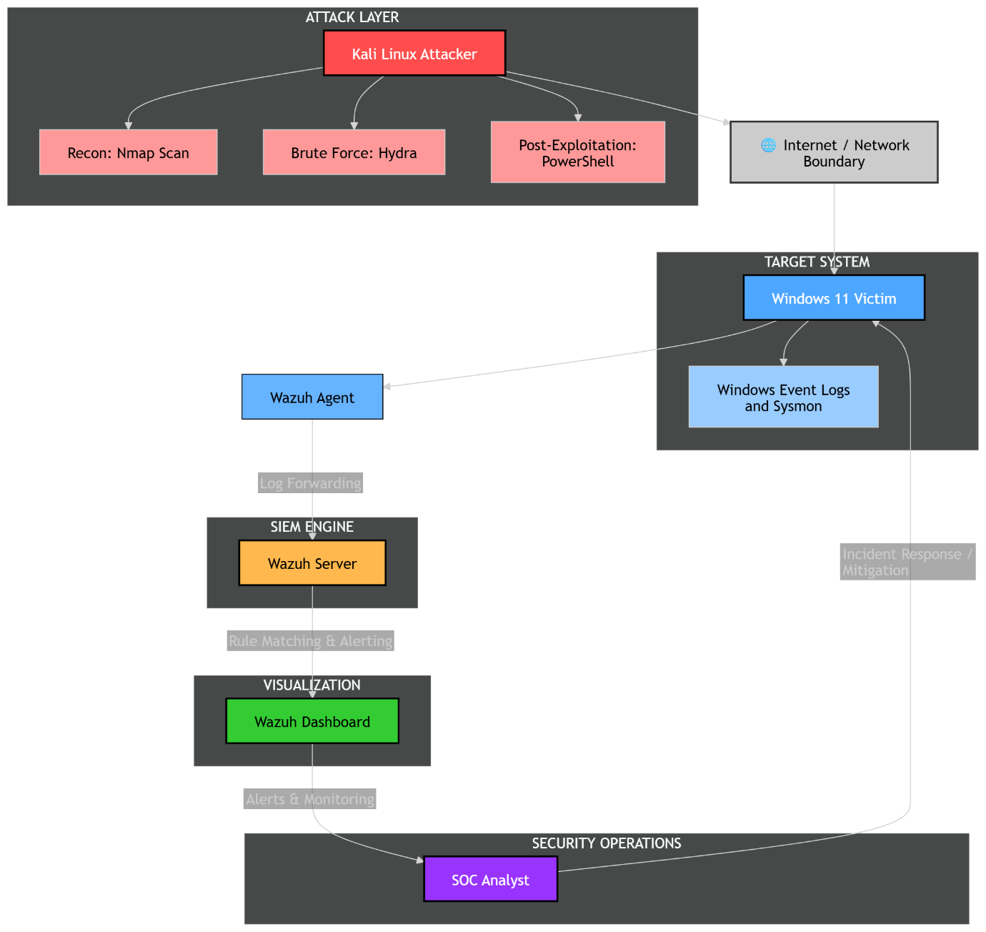
This architecture enabled centralized log collection, processing, and visualization, similar to real SOC environments.

3. Scope of Analysis
- Monitoring Duration: ~30 days
- Total Logs Analyzed: 100,000+

- Primary Log Sources:
  - Windows Security Logs
  - Sysmon Event Logs
  - Wazuh Alert Data
Focus Areas
- Authentication behavior and anomalies
- Process execution patterns
- Network-related activity
- Correlation of alerts across time

4. Incident Timeline (Attack Narrative)
Phase 1 — Baseline Activity
During the initial phase, system behavior remained stable with consistent log generation patterns. Authentication attempts, process execution, and system logs reflected normal user activity with no unusual spikes.

Phase 2 — Attack Initiation (Brute-force Activity)
A sudden and noticeable increase in authentication failures was observed. Logs were dominated by Event ID 4625 (Failed Logon).
Key observations:
- Approximately 15,000 login attempts within 2–3 minutes
- Peak rate exceeding 100 attempts per second
- Repeated attempts from a single source IP
This pattern strongly indicates automated brute-force activity rather than manual login attempts.

Phase 3 — Peak Attack Activity
The attack reached its peak with:
- A sharp spike in log volume
- Alert generation increasing by approximately 300–400% compared to baseline
- Continuous authentication failures without successful logins

Phase 4 — Execution Activity (PowerShell)
Process execution logs showed limited PowerShell activity captured through Sysmon (Event ID 1). However, only a small number of alerts were generated, indicating that while logging was enabled, detection rules were not sufficiently tuned.

Phase 5 — Reconnaissance Activity
Network scanning activity was performed using Nmap. Despite active scanning, no significant alerts were generated, highlighting limitations in host-based detection.

Phase 6 — Post-Attack State
- No successful authentication observed
- No evidence of persistence or lateral movement .
- System remained secure

5. Log & Threat Analysis

5.1 Log Volume Analysis
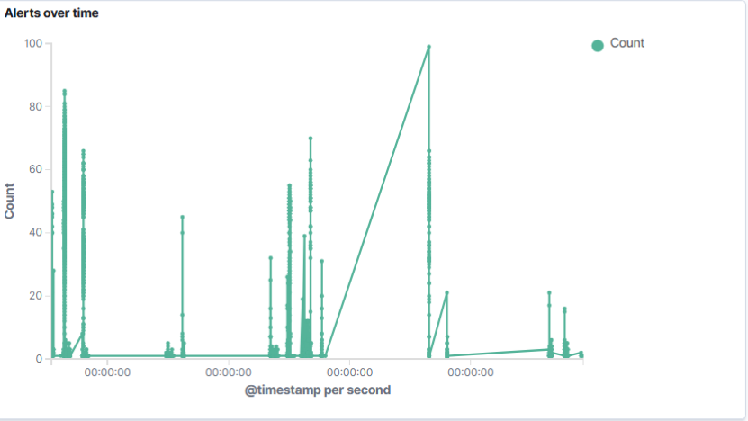
Over the monitoring period, more than 100,000 log events were generated. During baseline conditions, log activity remained stable with predictable variations. However, during the attack phase, a sudden and concentrated spike in log volume was observed.
Unlike normal fluctuations, this spike occurred within a very short time window, indicating burst activity rather than gradual increase. This type of behavior is commonly associated with automated attack tools.
From an analytical standpoint, identifying this spike was critical as it helped isolate the exact timeframe of malicious activity without initially relying on individual log inspection.
Analyst Insight:
Time-based anomalies often serve as the first indicator of suspicious behavior. In this case, the log spike directly pointed to the attack window and guided further investigation.

5.2 Authentication Analysis
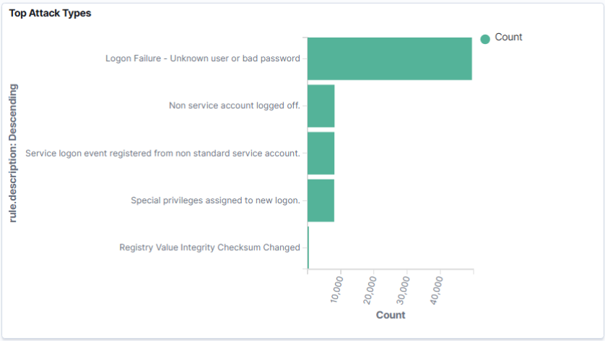
A deeper inspection of authentication logs revealed that Event ID 4625 dominated the dataset during the attack period.
Key characteristics:
- Extremely high frequency of failed login attempts
- Targeting of privileged accounts
- No successful authentication events recorded
- Uniform failure responses across attempts
The consistency and speed of these attempts clearly indicate automation. Human login attempts typically show variation in timing and behavior, whereas this activity was highly structured and repetitive.
Analyst Insight:
The combination of high frequency, consistency, and absence of successful logins confirms this as an automated brute-force attack rather than accidental user errors.
This behavior aligns with MITRE ATT&CK T1110 (Brute Force).

5.3 Process Execution Analysis
Process creation logs (Sysmon Event ID 1) were analyzed to detect any suspicious execution behavior. While PowerShell activity was observed, it generated only a limited number of alerts.
This indicates that:
- Logging mechanisms are functioning
- Detection rules are not sufficiently detailed
The lack of contextual information, such as command-line arguments, reduces the ability to distinguish between legitimate and malicious usage.
Analyst Insight:
PowerShell is frequently used in attacks, but effective detection requires deeper inspection of command patterns rather than simple execution logging.

5.4 Network Activity Analysis
Reconnaissance activity using Nmap was performed, but no significant alerts were detected.
This limitation arises because:
- The setup relies primarily on host-based logs
- Network-level visibility is absent
Without packet-level or flow-based monitoring, scanning activity often goes undetected.
Analyst Insight:
This reflects a real-world limitation. Effective detection of reconnaissance requires additional tools such as network sensors or intrusion detection systems.

5.5 Raw Log Verification
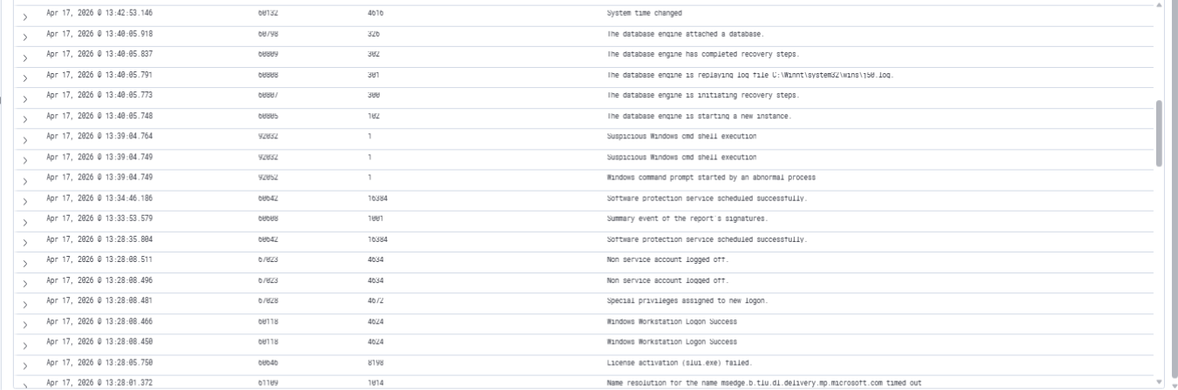
To ensure accuracy, raw logs were manually reviewed instead of relying solely on dashboard visualizations.
Findings:
- Repeated authentication failures with identical structure
- Timestamps closely spaced within milliseconds
- Consistent source IP across events
This confirmed that the patterns observed in the dashboard were backed by actual log data.
Analyst Insight:
Validating alerts against raw logs is essential to ensure that conclusions are based on real data rather than visualization artifacts.

5.6 Cross-Event Correlation
By combining authentication logs, execution logs, and timeline data, a complete attack pattern was established:
- Sudden spike in failed logins
- High-frequency repetition
- Single-source origin
- No successful compromise
Analyst Insight:
Correlation across multiple data points transforms isolated logs into a meaningful attack narrative, which is a key skill in SOC operations.
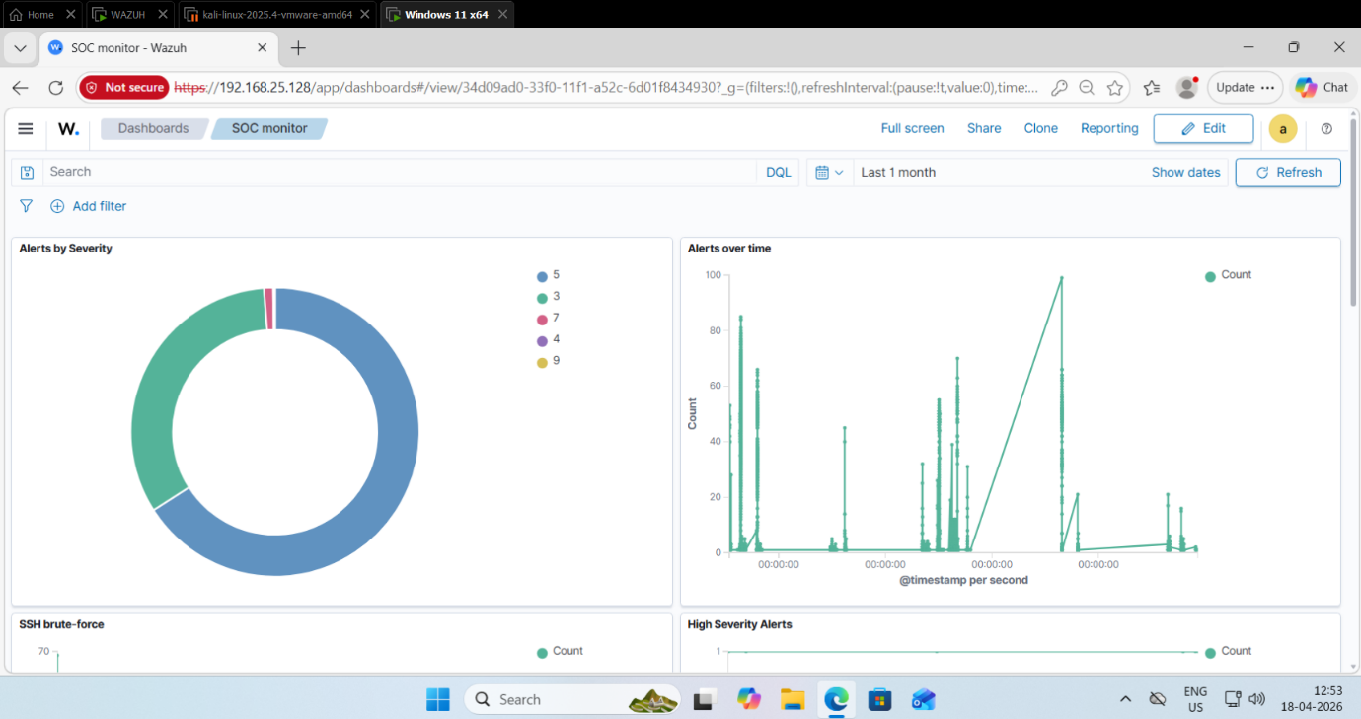

6. Event Correlation
A more focused correlation analysis was performed to understand relationships between events across time, source, and behavior.
The following patterns were consistently observed:
- Authentication failures occurring at extremely high frequency
- Events clustered within a short and well-defined time window
- All activity originating from a single IP address
- No transition from failed to successful authentication
- Lack of follow-up activity such as privilege escalation or lateral movement
When viewed individually, these events may appear as repeated login failures. However, when correlated across time and behavior, they clearly represent an automated attack sequence.
The absence of variation in attack behavior further strengthens this conclusion. Manual attempts typically show irregular patterns, whereas this activity was uniform and systematic.
Analyst Insight:
Event correlation is critical in distinguishing malicious behavior from normal system activity. In this case, correlation confirms that the observed activity is a structured brute-force attack rather than random login failures.

7. Detection Capability Assessment
Detection Area | Status
Brute-force Detection | Strong
PowerShell Detection | Partial
Reconnaissance Detection | Weak

8. MITRE ATT&CK Mapping
Technique | ID | Evidence
Brute Force | T1110 | Authentication failures
Command Execution | T1059 | PowerShell activity
Network Discovery | T1046 | Scanning behavior

9. Detection Gaps & Limitations
- Limited detection for reconnaissance activity
- Insufficient PowerShell monitoring depth
- No network-level visibility
- Dependence on default SIEM rules

10. Incident Severity & Impact
- Severity: High
- Attack Type: Brute-force authentication attack
- Impact: Unauthorized access attempt
- Outcome: Attack unsuccessful

11. Response & Mitigation
- Implement account lockout mechanisms
- Block malicious IP addresses
- Improve SIEM rule tuning
- Enable enhanced logging for PowerShell
- Integrate network monitoring tools

12. Analyst Observations
The investigation demonstrates that while SIEM tools are effective at detecting high-volume attack patterns, they require continuous tuning to improve detection coverage. The absence of certain detections highlights realistic limitations rather than system failure.

13. Conclusion
The SOC simulation successfully replicates real-world monitoring and detection workflows. While brute-force activity was effectively identified, limitations in detecting execution and reconnaissance emphasize the need for enhanced visibility and detection engineering.

